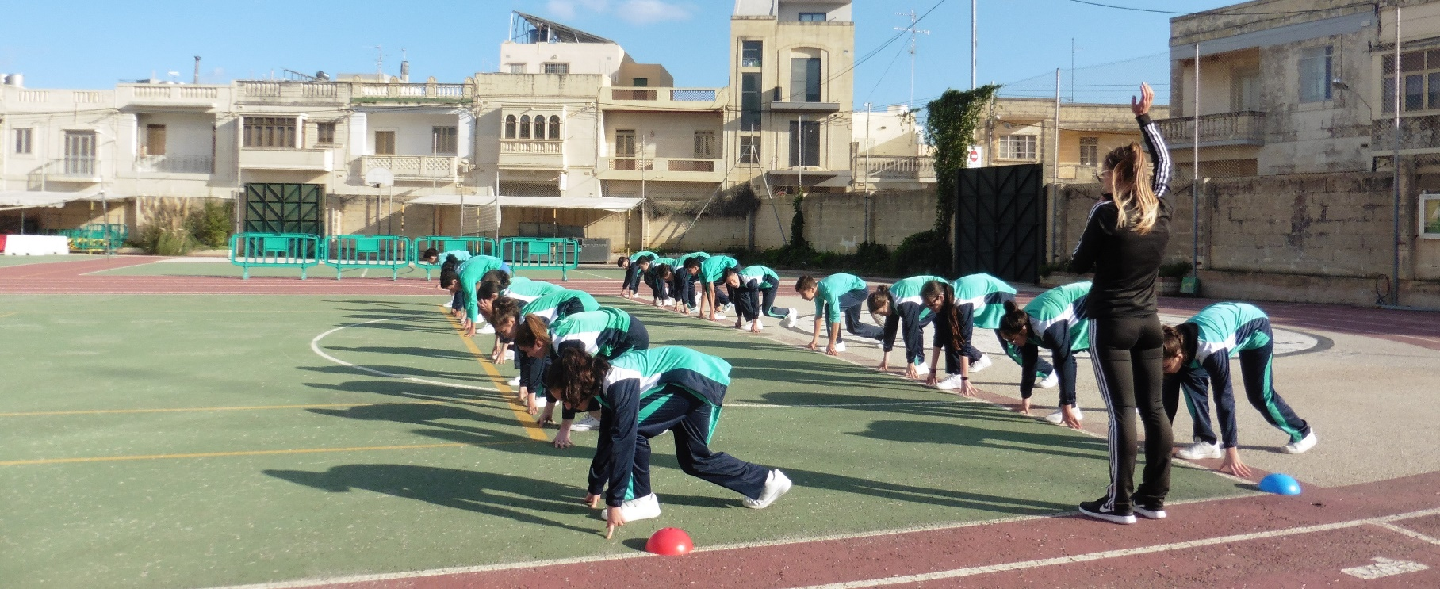
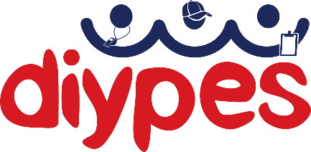
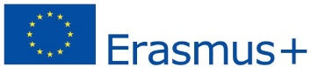

DIYPES (Do it yourself! A participative approach to increase participation and engagement of high school students in physical education and sport classes) project is an idea born from the wish of changing behaviors related to physical education (PE) that can further influence physical, psychological, cognitive and social development of individuals. In the DIYPES project high school students, PE teachers, researchers and PE specialists work together to find solutions to make PE classes more attractive to students. The project is under Erasmus+ Sport program, started in January 2017 and lasts for two years.
DIYPES project seeks to identify and describe core educational objectives and development practices that can improve PE classes in the national curriculum of 5 European countries: Albania, Italy, Malta, Romania, and Slovakia. The project tested the feasibility and effectiveness of a three-month intervention focused on a participatory approach to physical education and sport classes in each country. It also seeks to develop a set of scenarios applicable at the European level with regards to models for building innovative participatory approaches to PE classes.

Three months testing the change!
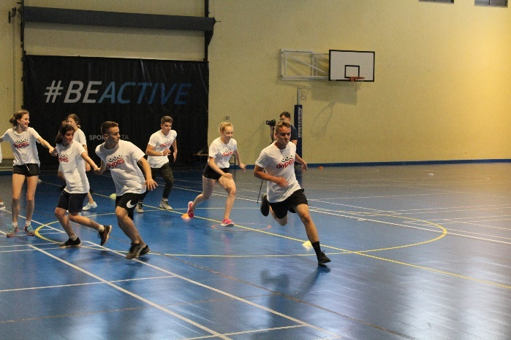
The 3 month-intervention has been implemented on a population of about 1250 students from 15 high-schools in the partner countries. The activities carried out ensured the collection of significant information on planning and developing the PE classes.

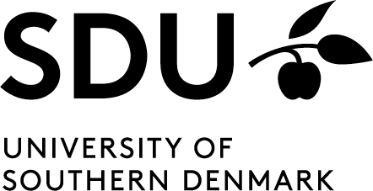

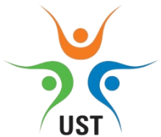
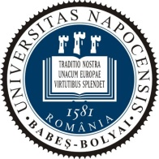
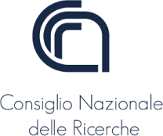
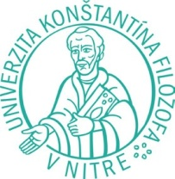
FOUNDATION FOR THE PROMOTION OF SOCIAL INCLUSION MALTA

Albania

University of Sports Tirana (UST)

DIYPES intervention implemented in three different high schools: urban area “Abaz Shehu” school – Tepelena, peri-urban area “Sali Nivica” school - Memaliaj and in rural area “Adem Alushi” school – Krahes. Infrastructure situation was different in each of the settings (from very good to limited), while equipment situation was poor in all the settings. The students’ needs were assessed through focus groups which identified their preference for group activities such as traditional sports, volleyball, football and other modern sports such as martial arts. The PE teachers applied the station method in group sports: students were organized in small groups performing simultaneously different exercises in diverse stations. DIYPES funds were used to purchase the sport equipment needed i.e. balls, pyramids and marker clothing. Considering the infrastructure and equipment of the settings and the socio-economic background of the region, the results of the project intervention were amazing. There was an increased participation and engagement of the students in PE classes and a development of social values as socialization and team work.

Italy

The National Research Council (CNR)

DIYPES project involved three high schools in Rome: Liceo Cavour, Liceo Orazio and the Istituto di Istruzione Superiore Domizia Lucilla-Sezione Agraria, respectively central, neighborhood and rural area. Focus groups were organized to identify students’ needs, which resulted in the proposal of different sports and innovative activities, the organization of the available school spaces and times as functionally as possible to facilitate and support PE and the increase of responsibilities for the students through the performance of activities simultaneously in small groups. DIYPES project budget was instrumental in funding some equipment for the implementation of the interventions. Some proposals were particular such as the introduction of music during the lessons, while other were more “traditional” such as changing warm-up routines, introducing specific sport exercises, having more competitions between classes, or increasing awareness of the evaluation method. The students’ proposals were discussed with the PE teachers and then trialed with the DIYPES intervention in March-June 2018.

Malta

Foundation for the Promotion of Social Inclusion in Malta (FOPSIM)

Three schools engaged in DIYPES were St Theresa College Secondary School, St Edward’s College and St Thomas More College, Middle & Secondary School. The intervention was methodically applied such as house-points for rewarding students for participation, gamificated activities for warming up and competition-based activities. In addition, detailed explanation on exercises/tasks and their benefits to fitness condition and the increase of teachers’ communication with students and team work activities were actively carried out. New equipment was purchased by the project fund which included a volleyball net, bibs and gym equipment. This benefited the schools’ students within and beyond the project intervention.

Romania

Babeș-Bolyai University (BBU)

DIYPES was implemented in three high schools, two from Cluj-Napoca municipality (Mihai Eminescu and Eugen Pora) and one (Gelu Voievod) from a rural area in Cluj County. While the schools’ PE infrastructure presented different limitations, namely, crowded sports hall, small one, and insufficient equipment respectively, the majority of the students (from all 3 high-schools) suggested implementing similar innovations. There were new/group activities/sports, class based and school-based competitions and more support in preparing for evaluation norms. The research team collected, analyzed, synthesized and presented 9 different intervention plans (one for each class) to be used by the PE teachers, focusing on the students’ suggestions, mainly introducing dynamic games as warm-up activities, learning new technical elements through contests, and introducing optional activities (body building and badminton). Good practices have been identified and collected throughout the entire timeframe of intervention implementation.

Slovakia

Constantine the Philosopher University in Nitra- Faculty of Education (CPU)

Three high schools participated to the DIYPES project are Spojená škola Nitra, Secondary Grammar School Golianova Nitra and Secondary Grammar School Šurany, respectively central, neighborhood and rural area. The students’ perspectives on PE were the starting point for DIYPES intervention. Their proposals were collected through focus group meetings and then delivered to the PE teachers for negotiation. Through the 1000 euros from the DIYPES funds, new equipment was bought for the schools involved. A different intervention plan was devised for each class participating. In total 9 interventions were implemented. PE teachers following up with the students’ suggestions modified the lesson (March-May 2018) varying on the activities and introducing group and single students’ competition-based activities, highly appreciated by all of the students. At the end of the project the students’ perspectives were collected again, thus determining what could improve their participation in PE lessons.

What’s next?

The results of each intervention and feedback from all participants and other parties involved will be compiled in a unitary guideline for good practice that could be used at European level and encourage the use of participatory approaches in the planning and development of PE classes. Such booklet will shed new light on the best practices in enhancing the interest of teenagers towards Physical Education in the school setting. The practices collected could then be tested in other countries. Feedback on them may help in building a more comprehensive collection of information on Physical Education’s most effective practices for teachers, school and national curricula in engaging teenagers in practicing it.

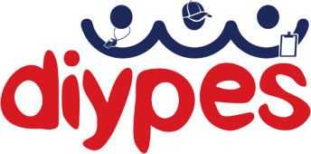
http://diypes.eu/
info@diypes.eu

