Dissemination report - Jaromír Šimonek (Nitra, Slovakia) – project DC4AC

The following activities have been accomplished during the project:
- Publications and articles in journals
Šimonek, J. 2016. Medzinárodný projekt „Dvojitá kariéra“ v športe. In Šport a rekreácia. Zborník vedeckých prác. Ed. Jaroslav Broďáni. Nitra: KTVŠ PF UKF Nitra, s. 116-127. 1. vyd. ISBN 978-80-558-1018-8. (Circulation: 200 pieces)
Šimonek, J. 2016. Medzinárodný projekt „Duálna kariéra“ v športe. Náš čas XX, 2016, 2, s. 58. https://www.ukf.sk/images/nascas/NC2016-2-web1.pdf (Circulation: 200 pieces)
Šimonek, J. 2017. Odborný seminár k problematike „dvojitých kariér“ v športe. Tel. Vých. Šport, 27, 2017, 1, p. 47-48. (Circulation: 300 pieces)
Šimonek, J. 2017. Výsledky dotazníkového zisťovania názorov vrcholových športovcov na starostlivosť štátu o reprezentantov na Slovensku. Opinions of Slovak elite athletes on dual career in sport. In Zborník z vedeckej konferencie s medzinárodnou účasťou. Patince 11.-13.5.2017. (publication in press).
Šimonek, J. 2017. Dvojité kariéry športovcov na Slovensku. Scientific monograph. Nitra: UKF. 84 s. ISBN 978-80-558-1152-9. (Circulation: 200 pieces)
- Events promoting the project:
- Meeting of sport organizations (May 2016) at the Faculty of Physical Education & Sport in Bratislava, Slovakia - Creation of promo materials for the project DC4AC (Roll-up banner – see picture below): (approx. 80 experts from sport area)
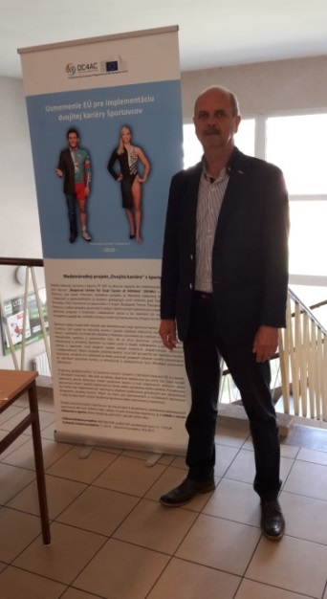
- Publication of the Guidelines on implementation of EU policy concerning double careers of athletes in Slovakia (in Slovak language). (Circulation: 250 pcs.)

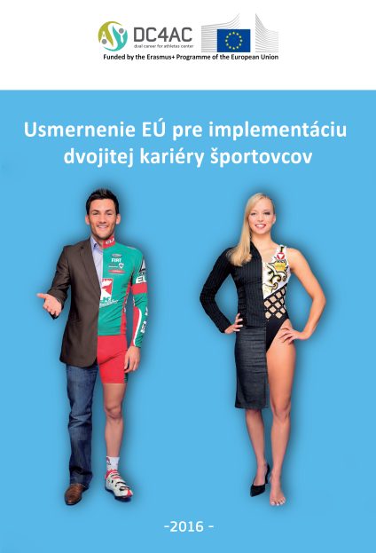

- Preparation of the content of the new Slovak domain of the project DC4AC.sk
- Organization of the national workshop of experts on DC4AC in sport under the tutorship of Faculty of Education CPU in Nitra and gestorship of the Ministry of Education with the support of the project DC4AC (13 invited speakers, 40 participants from sport unions, secondary sport schools, National Sport Centre, Ministry of Education, Slovak Association of University Sports) (October 2016, Patince, Slovakia) (approx.. 40 participants from the area of sport).
- Organizing 3 round table discussions with stakeholders on dual career in Slovakia (May 2017, Mojmírovce, Slovakia). (approx.. 40 stakeholders from the area of sport, ministries of sport, social welfare, economy, insurance, labour, NGO, ADECCO, University sport, etc.)
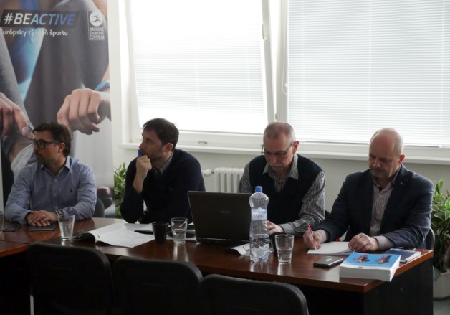
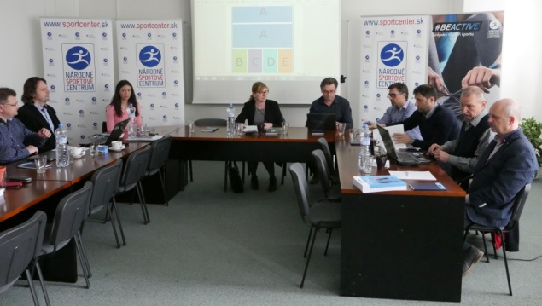
- Production of promotion materials with the logo of the project (approx. 500 pieces) and their distribution at workshops, seminars, conferences, student scientific activities.
- Publication of partial results of the solution of the project at the Internet:
- www.DC4AC.sk
- http://www.sportcenter.sk/

